***Salinity***

Step 1. Fill a 1000 mL beaker with 300 mL deionized water. Turn the sensor on in continuous measurement mode and start a stopwatch at the exact moment of the first measurement. Dip the sensor head in the water and ensure that there are no bubbles caught inside the conductivity probe. Note the time into the test that the sensor goes into and out of the water. Sample data formatted for the R code to produce a calibration curve are provided in *salinity_test_additions_TEMPLATE.csv* in the project GitHub.

Step 2. Weigh out ~2 g aquarium salt and note the exact mass.

Step 3. Dissolve the salt completely in the water. Dip the sensor in the beaker, and note the time into the test that the sensor goes into and out of the water.

Step 4. Repeat steps 2 and 3 until the salinity in the beaker is ~35 ppt.

Step 5. Turn off the sensor using the slide switch. Download the data from the SD card into the same folder as the salt additions file.

Step 6. Set the filenames and file path in *calibrations_markdown.Rmd* to the appropriate values to produce a calibration curve as in Figure 1.

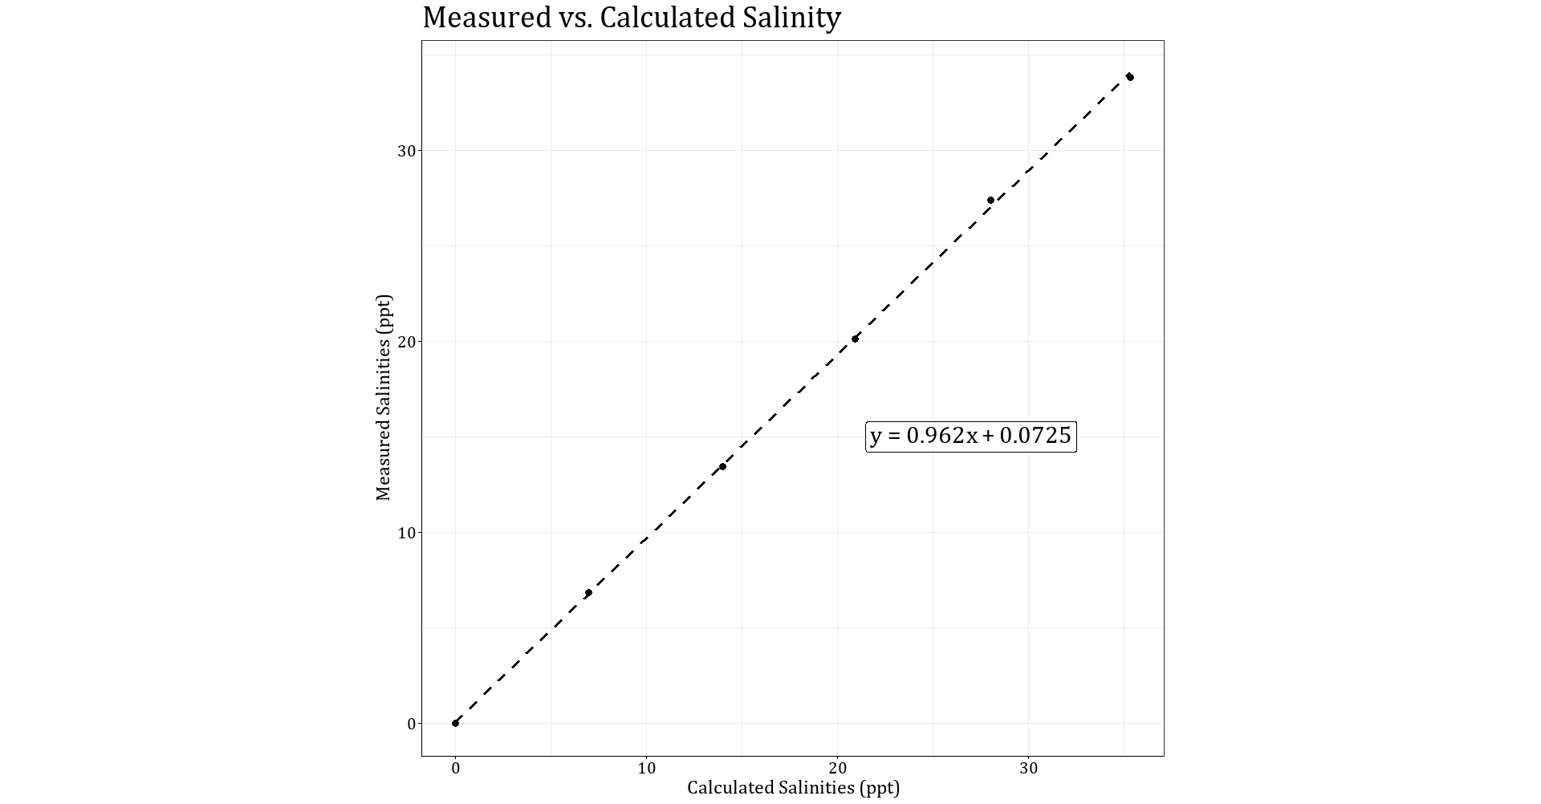

Figure 1. Salinity calibration curve.

***Turbidity/Suspended Sediment Concentration***

Note: this method was not able to produce­­ an accurate calibration curve. Further work is needed to reduce the return from the bucket walls. Other calibrations with natural sediment include up to 100x greater suspended sediment concentrations (Eidam, et al., 2021). An alternative method is included in the OpenOBS Build Guide, linked in the project GitHub.

Step 1. Fill a basin with enough water such that when the sensor head is dipped in, it is at least 30 cm away from the walls and floor of the basin. Calculate the exact volume of water by filling the basin from a hose with a known volume flow rate and timing the filling. Turn the sensor on in continuous measurement mode and start a stopwatch at the exact moment of the first measurement. Dip the sensor head in the water. Note the time into the test that the sensor goes into and out of the water. Sample data formatted for the R code to produce a calibration curve are provided in *turbidity_test_points_TEMPLATE.csv* in the project GitHub.

Step 2. Measure out ~3-5 g silt (< 63 μm) and note the exact mass. Fine material is preferable because it remains in suspension longer than coarse material.

Step 3. Pour the sediment into the basin. Stir the basin vigorously to get the material in suspension and dip the sensor in for 10-30 seconds. Note the elapsed time into the test that the sensor goes into and out of the water.

Step 4. Repeat steps 2 and 3 until estimated suspended sediment concentration is ~400 mg/L and the water appears visibly cloudy to the eye.

Step 5. Turn off the sensor using the slide switch. Download the test data from the SD card to the same folder as the sediment additions file.

Step 6. Set the filenames and file path in *calibrations_markdown.Rmd* to the appropriate values to produce a calibration curve as in Figure 2.

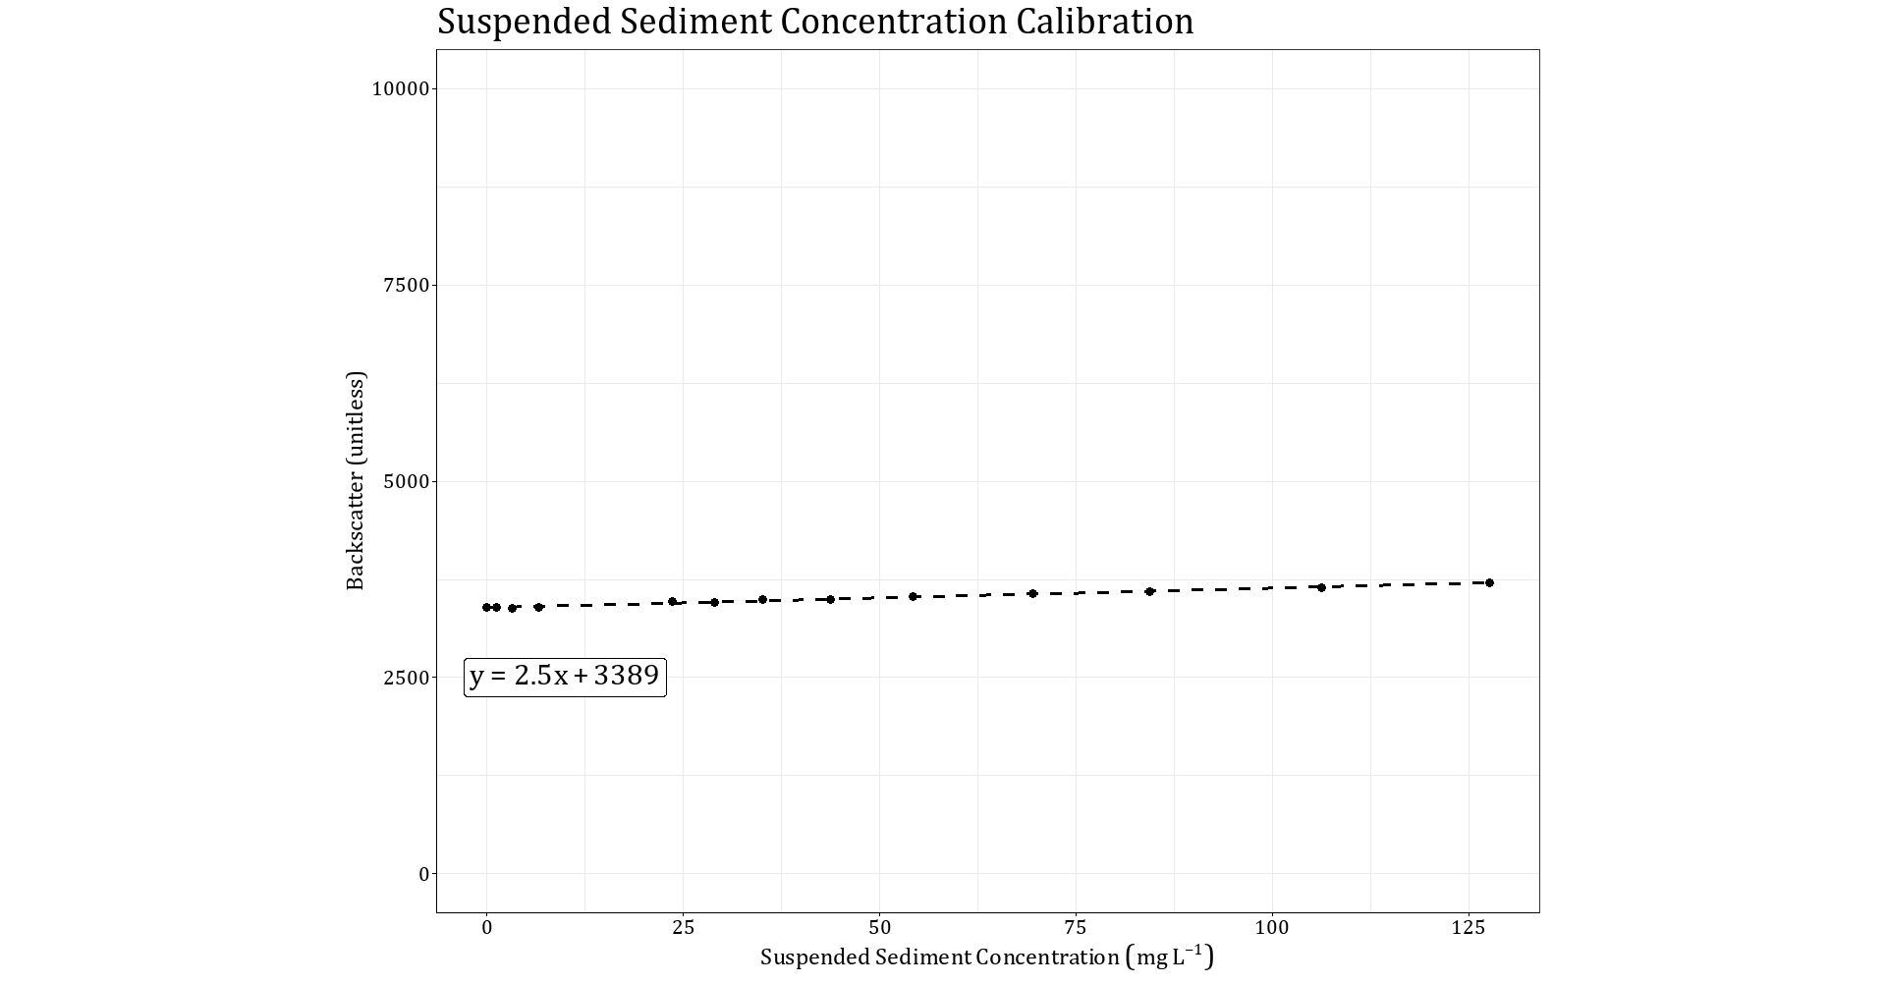

Figure 2. Suspended sediment concentration calibration curve. There is a high backscatter return even at low concentrations because emitted light reflects off the walls and floor of the basin.

***Dissolved Oxygen***

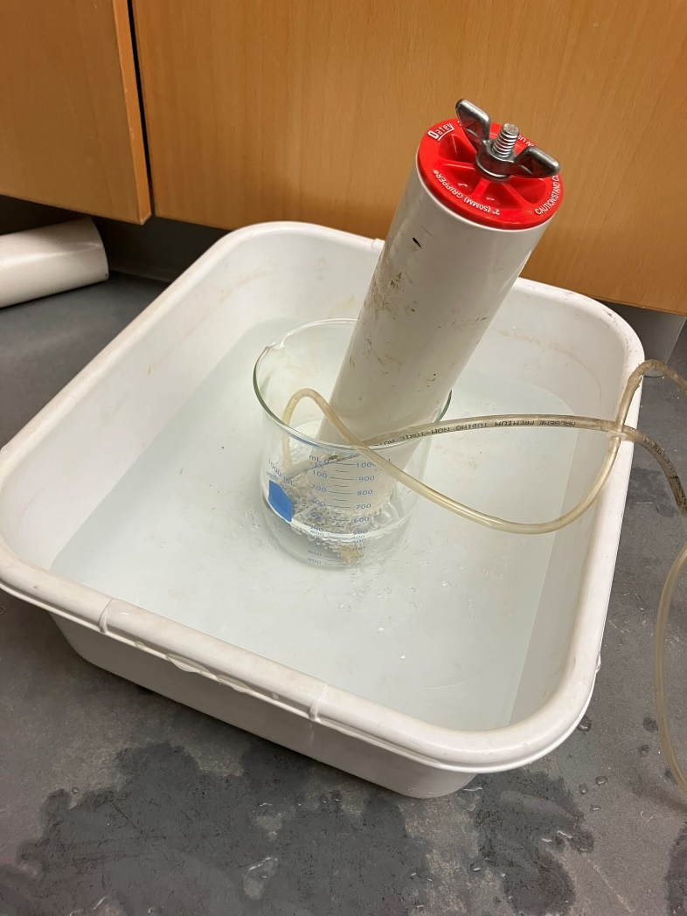

Figure 3. Dissolved oxygen calibration experimental setup.

Step 1. Fill a 1000 mL beaker with 300 mL deionized water. Use an aquarium bubbler to aerate the water.

Step 2. Fill a larger, shallow bin with ice and water. Set the beaker with deionized water and bubbler in the bin and wait at least 30 minutes to allow the temperature to equilibrate and oxygen concentration to reach saturation.

Step 3. Turn the sensor on in continuous measurement mode and set it in the beaker. Leave the sensor until the ice melts. This may take up to 12 hours.

Step 4. Load the test data onto the computer. Change the file path and filename in *calibrations_markdown_Rmd* to the appropriate values to visualize the relationship between temperature, oxygen concentration at saturation, and measured oxygen concentration as in Figure 4.

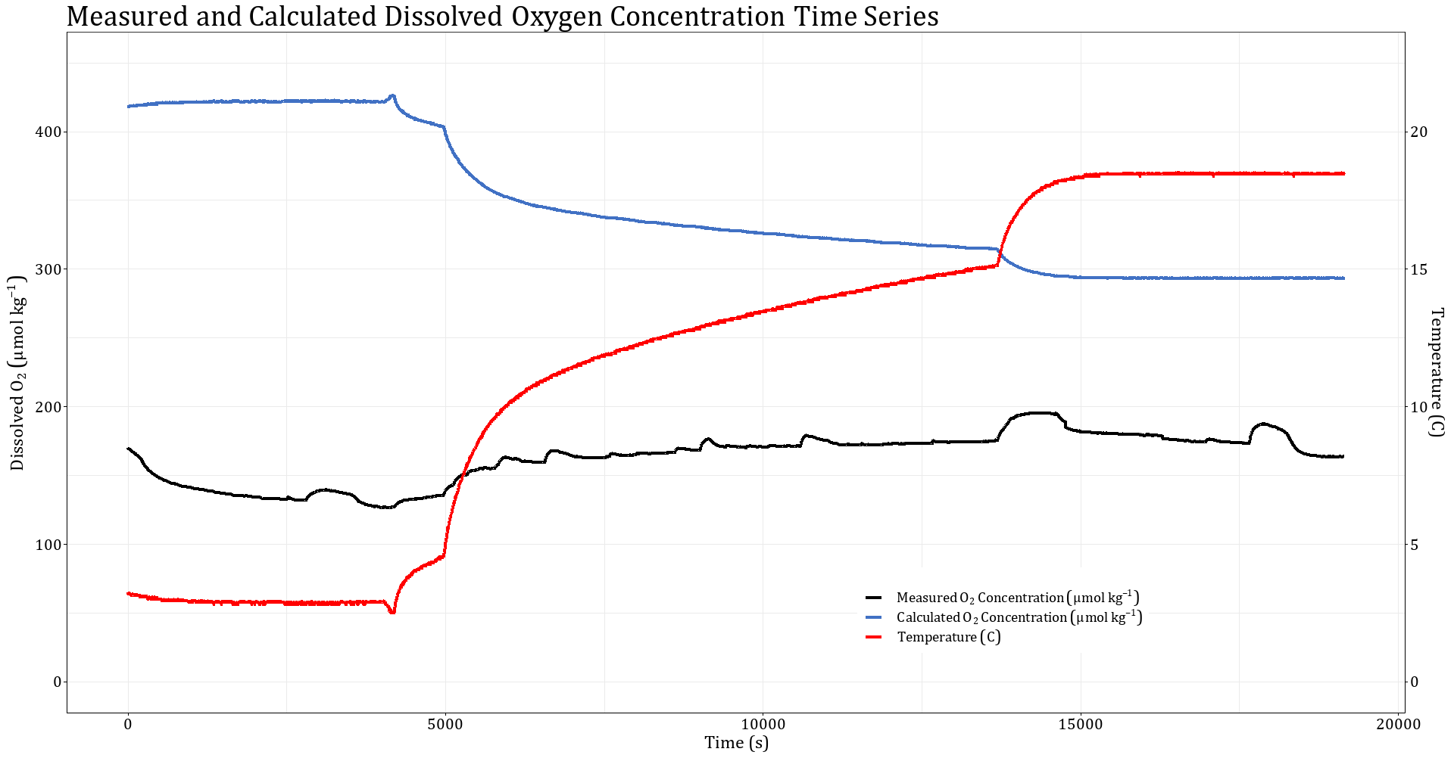

Figure 4. Dissolved oxygen calibration curve. This test was conducted after the sensor membrane was damaged.